Sequence:
1 MAQAHSAPLT GYRIAVTSAR RAEELCALLR RQGAEVCSAP AIKMIALPDD DELQNNTEAL
61 IADPPDILVA HTGIGFRGWL AAAEGWGLAN ELLESLSSAR IISRGPKATG ALRAAGLREE
121 WSPDSESSHE VLEYLLESGV SRTRIAVQLH GAADSWDPFP EFLGGLRFAG AQVVPIRVYR
181 WKPAPLGGVF DHLVTGIARR QFDAVTFTSA PAAAAVLERS RELDIEDQLL AALRTDVHAM
241 CVGPVTSRPL IRKGVPTSAP ERMRLGALAR HIAEELPLLG SCTFKAAGHV IEIRGTSVLV
301 DDSVKPLSPS GMAILRALVH RPGGVVSRGD LLRVLPGDGS DTHAVDTAVL RLRTALGDKN
361 IVATVVKRGY RLAVDSRHDD V

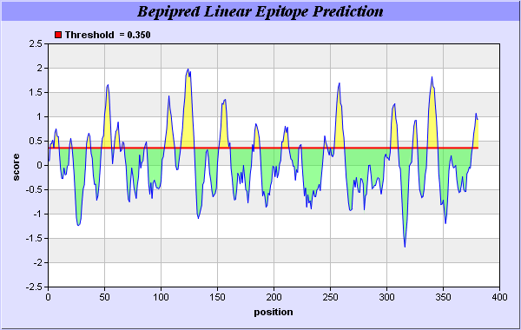

Predicted epitopes:
No. | Start Position | End Position | Peptide | Peptide Length
1 | 2 | 9 | AQAHSAPL | 8
2 | 19 | 21 | ARR | 3
3 | 34 | 37 | AEVC | 4
4 | 48 | 56 | PDDDELQNN | 9
5 | 59 | 63 | ALIAD | 5
6 | 66 | 67 | DI | 2
7 | 86 | 87 | WG | 2
8 | 103 | 112 | SRGPKATGAL | 10
9 | 118 | 129 | REEWSPDSESSH | 12
10 | 152 | 161 | AADSWDPFPE | 10
11 | 181 | 181 | W | 1
12 | 183 | 187 | PAPLG | 5
13 | 207 | 213 | FTSAPAA | 7
14 | 223 | 224 | LD | 2
15 | 245 | 247 | VTS | 3
16 | 250 | 250 | L | 1
17 | 254 | 262 | GVPTSAPER | 9
18 | 304 | 310 | VKPLSPS | 7
19 | 323 | 327 | GGVVS | 5
20 | 336 | 345 | PGDGSDTHAV | 10

